

**Seminar Report on**

CODE BLOCK PHASE 2:

CONTEMPORARY APPLICATIONS

OF AI

**Conducted on 12th April, 2025 By**

**Department of Computer Science and Engineering**

**Sri Venkateshwara College of Engineering**

Vidyanagar, Kempegowda International Airport Road, Bengaluru – 562157 https://svcengg.edu.in



**Department of Computer Science and Engineering**

**Event Name: Contemporary Applications in Generative AI. Event Type (Seminar/Workshop/FDP): Seminar.**

**Date: 12th April 2025.**

|  |  |  |  |
| --- | --- | --- | --- |
| **S. No** | **Parameters** | **Enclosed**  **(Yes/No)** | **Remarks** |
| 1 | Signed copy of Event summary report | **Yes** |  |
| 2 | MS-Team approval / Permission letter from the principal | **Yes** |  |
| 3 | Banner or Poster | **Yes** |  |
| 4 | Visio, Mission, PEOs, POs and PSOs | **Yes** |  |
| 5 | Professional Body approval mail (IETE/IEEE etc.) | **Yes** |  |
| 6 | Event invitation and/or Agenda | **Yes** |  |
| 7 | Program Overview (workshop/Seminar/FDP Etc..) | **Yes** |  |
| 8 | Program Objectives | **Yes** |  |
| 9 | Program Outcomes and FDP/Seminar/Workshop | **Yes** |  |
| 10 | Outcomes mappings | **Yes** |  |
| 11 | Key Takeaways of the Program | **Yes** |  |
| 12 | Topics Covered (schedule) | **Yes** |  |
| 13 | Highlights of the Program | **Yes** |  |
| 14 | Day wise Proceedings | **Yes** |  |
| 15 | Final Assessment (if Any) | **NA** |  |
| 16 | Feedback | **Yes** |  |
| 17 | Best Practices | **Yes** |  |
| 18 | Gratitude and Thanks Note | **Yes** |  |
| 19 | Annexure-I: List of Participants and attendance copy (original). | **Yes** |  |
| 20 | Annexure-II: Feedback filled sample forms | **Yes** |  |
| 21 | Annexure-III: Sample certificates (Participants, Resource person,  volunteers and Prize won ) | **NA** |  |
| 22 | Annexure-IV: Glimpses of the event (event Photos with caption) | **Yes** |  |
| 23 | Annexure-V: Account statements and bills of the event | **Yes** |  |
| 24 | Soft copy uploaded | **Yes** |  |

Submitted By (Name & Sign) Accepted By (Name & Sign)

Mr. LOKESH M Mrs. ARCHANA M Dr. BAMA S



**Department of Computer Science & Engineering**

**Event Summary Report on**

**Name of the Event**: CODE BLOCK PHASE 2: CONTEMPORARY APPLICATIONS OF AI  
**Type of Event**: Seminar  
**Intended participants**: (Student/ Faculty/ Staff): Students  
**Associations**: IIC, IETE  
**Sponsored by**: Self  
**Date of the Event**: 12th April 2025  
**Time of the Event**: 9:00am to 1:30pm **Total Number of Participants**: 140  
**Platform used**: offline **Venue**: Auditorium

**Social media publication Link**:  
<https://www.instagram.com/p/DlS6RlNPJTZ/?igsh=OHRtOWlyaXE0eGRh>

**Registration Link (if any)**: NA **Meeting Link (if any)**: NA  
**Total Budget Approved**: Rs. 5,000 **Total Budget Used**: Rs. 5,000

**Details of the Resource Persons**:

**Mr. Sujeet Kumar**, Infosys Limited, Amsterdam, NL Head of AML, KYC Delivery,

Large European Bank, Bengaluru, Karnataka.

**Convenor**:  
**Dr. Mukesh Kumar Singh**  
HOD, CSE

**List of coordinators**: **Signatures:**

1. Mr. Lokesh M
2. Mrs. Archana M
3. Dr. Bama S

**HOD**

**MS-Team approval / Permission letter from the principal**

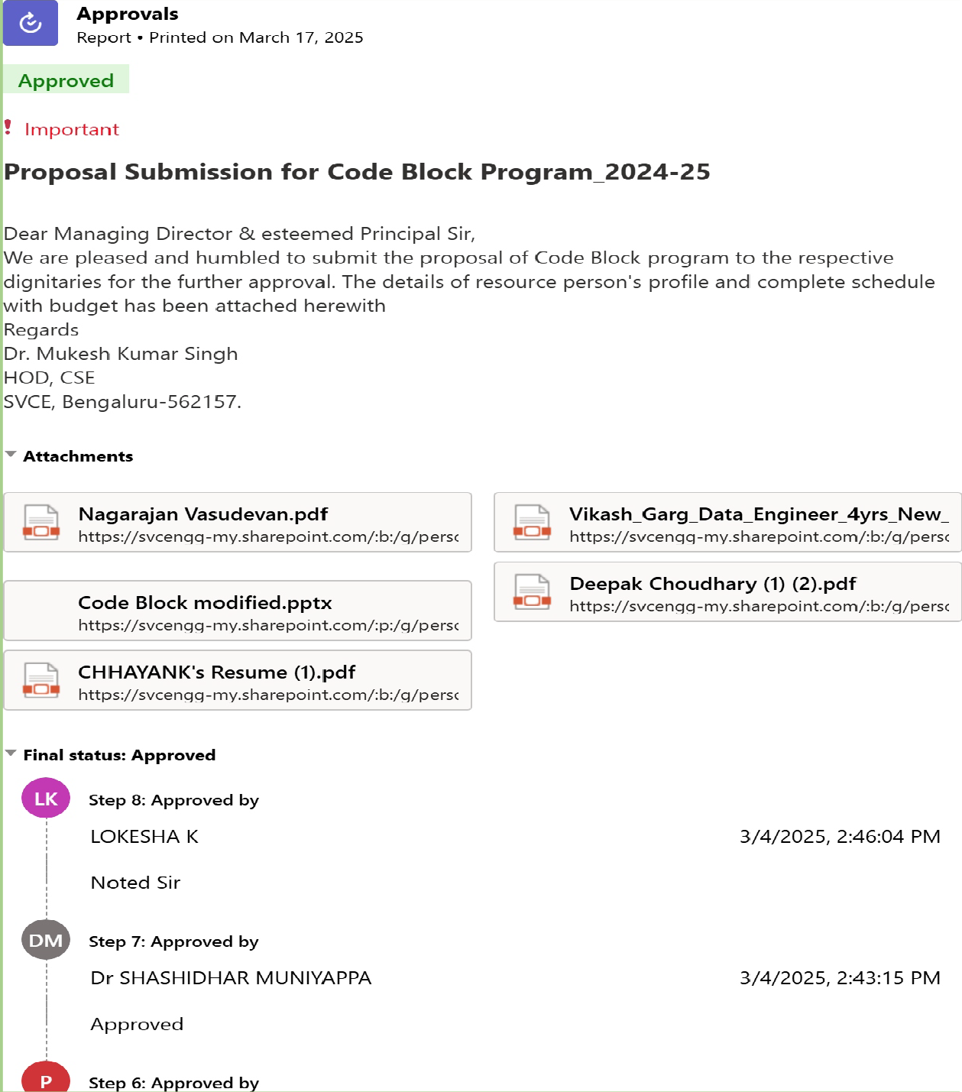

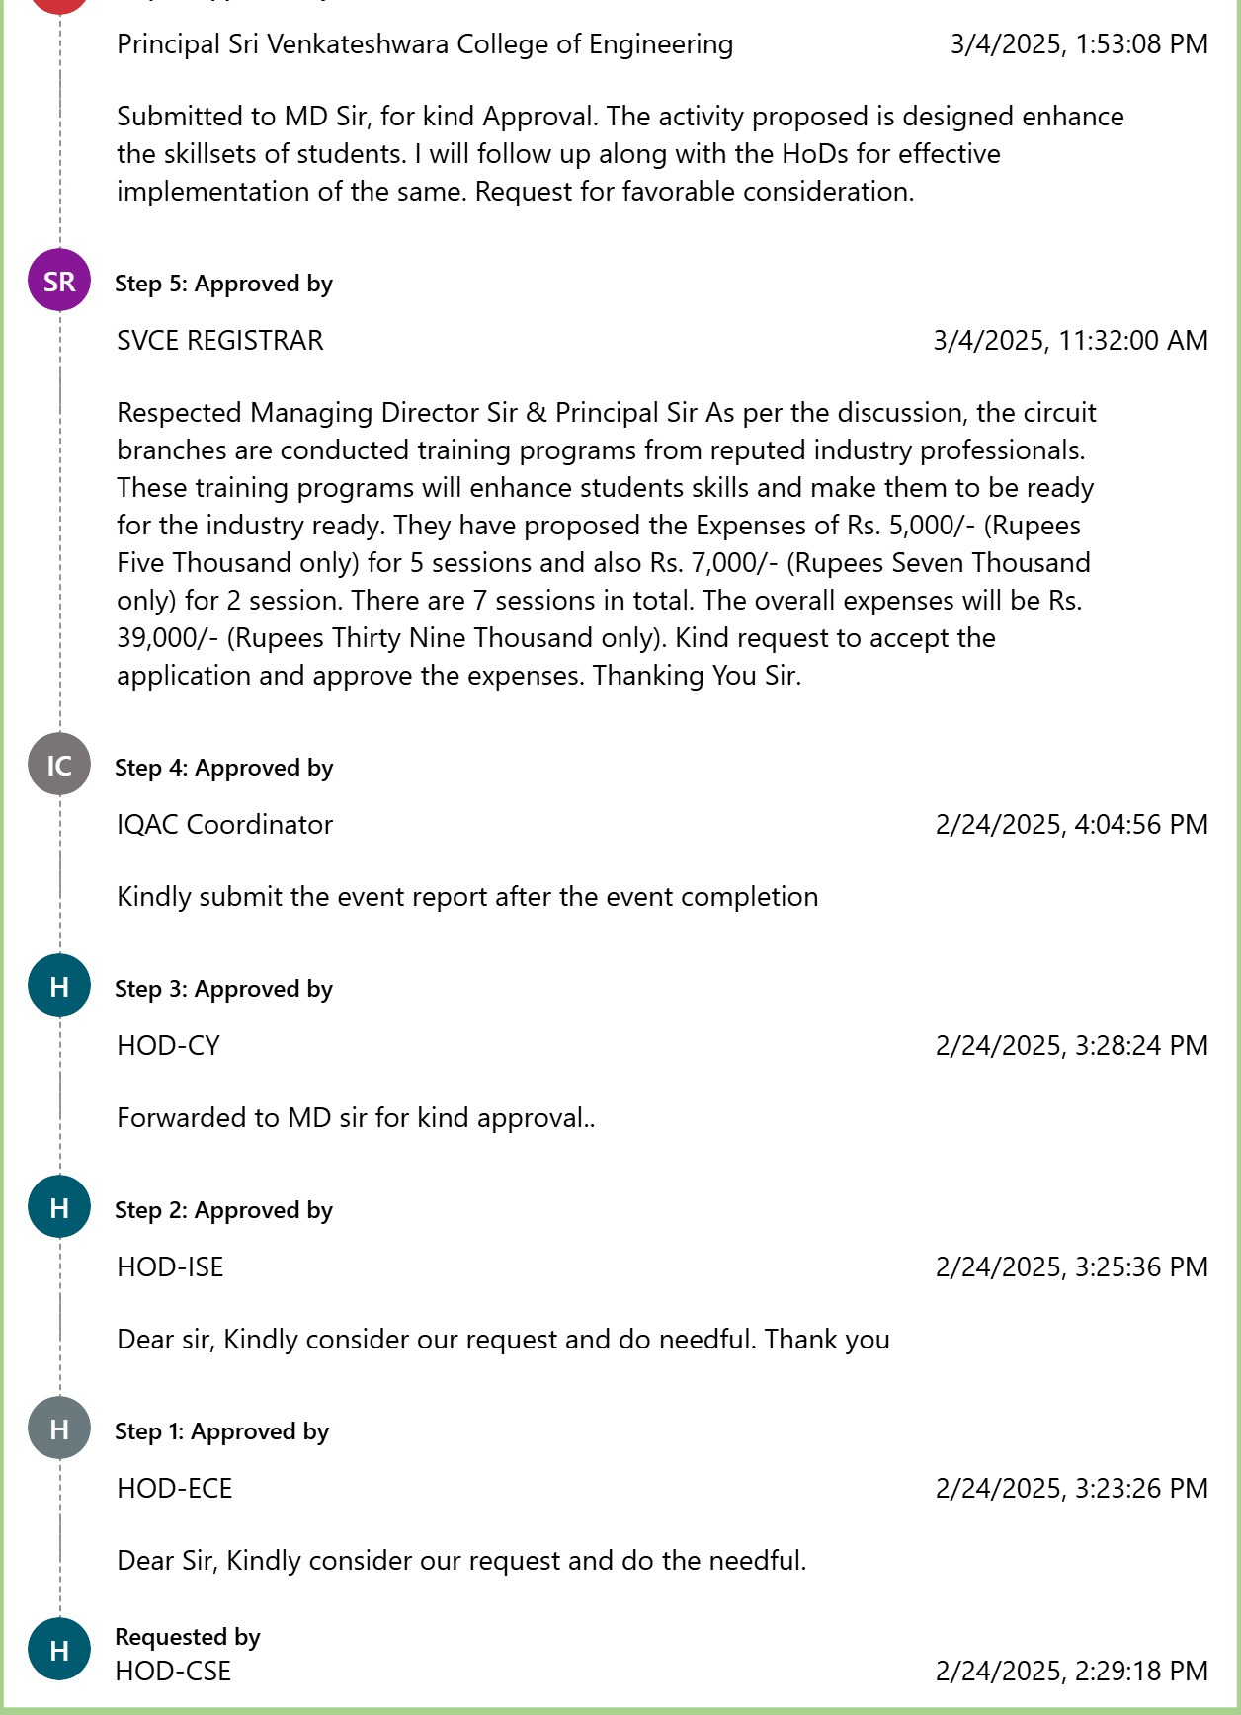

**Banner or Poster**

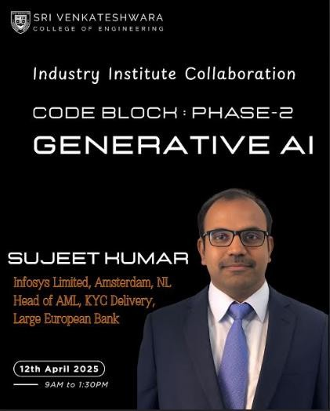

**Departmental Goal**

# Vision

To be a school of Excellence in Computing for Holistic Education and Research.

# Mission

## Mission 1:

Accomplish academic achievement in Computer Science and Engineering through student- centered creative teaching learning, qualified faculty members, assessment and effective usage of ICT.

## Mission 2:

Establish a Center of Excellence in a various verticals of computer science and engineering to encourage collaborative research and Industry-institute interaction.

## Mission 3:

Transform the engineering students to socially responsible, ethical, technically competent and Value added professional or entrepreneur through holistic education.

# Program Educational Objectives

## Knowledge

* Computer Science and Engineering Graduates will have professional technical career in inter disciplinary domains providing innovative and sustainable solutions using modern tools.

## Skills

* Computer Science and Engineering Graduates will have effective communication, leadership, team building, problem solving, decision making and creative skills.

## Attitude

* Computer Science and Engineering Graduates will practice ethical responsibilities towards their peers, employers and society.

# Program Specific Outcomes

## PSO 1

Ability to adopt quickly for any domain, interact with diverse group of individuals and be an entrepreneur in a societal and global setting.

## PSO 2

Ability to visualize the operations of existing and future software Applications.

# Program Outcomes

Engineering Graduates will be able to:

PO1: Engineering Knowledge: Apply knowledge of mathematics, natural science, computing, engineering fundamentals and an engineering specialization as specified in WK1 to WK4 respectively to develop to the solution of complex engineering problems.

PO2: Problem Analysis: Identify, formulate, review research literature and analyze complex engineering problems reaching substantiated conclusions with consideration for sustainable development. (WK1 to WK4)

PO3: Design/Development of Solutions: Design creative solutions for complex engineering problems and design/develop systems/components/processes to meet identified needs with

consideration for the public health and safety, whole-life cost, net zero carbon, culture, society and environment as required. (WK5)

PO4: Conduct Investigations of Complex Problems: Conduct investigations of complex engineering problems using research-based knowledge including design of experiments, modelling, analysis & interpretation of data to provide valid conclusions. (WK8).

PO5: Engineering Tool Usage: Create, select and apply appropriate techniques, resources and modern engineering & IT tools, including prediction and modelling recognizing their limitations to solve complex engineering problems. (WK2 and WK6)

PO6: The Engineer and The World: Analyze and evaluate societal and environmental aspects while solving complex engineering problems for its impact on sustainability with reference to economy, health, safety, legal framework, culture and environment. (WK1, WK5, and WK7).

PO7: Ethics: Apply ethical principles and commit to professional ethics, human values, diversity and inclusion; adhere to national & international laws. (WK9)

PO8: Individual and Collaborative Team work: Function effectively as an individual, and as a member or leader in diverse/multi-disciplinary teams.

PO9: Communication: Communicate effectively and inclusively within the engineering community and society at large, such as being able to comprehend and write effective reports and design documentation, make effective presentations considering cultural, language, and learning differences

PO10: Project Management and Finance: Apply knowledge and understanding of engineering management principles and economic decision-making and apply these to one’s own work, as a member and leader in a team, and to manage projects and in multidisciplinary environments.

PO11: Life-Long Learning: Recognize the need for, and have the preparation and ability for i) independent and life-long learning ii) adaptability to new and emerging technologies and iii) critical thinking in the broadest context of technological change. (WK8)

**IETE Approval**

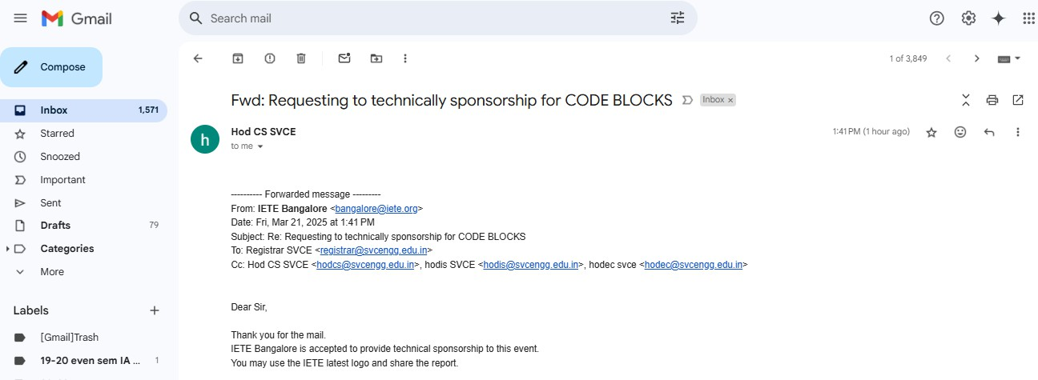

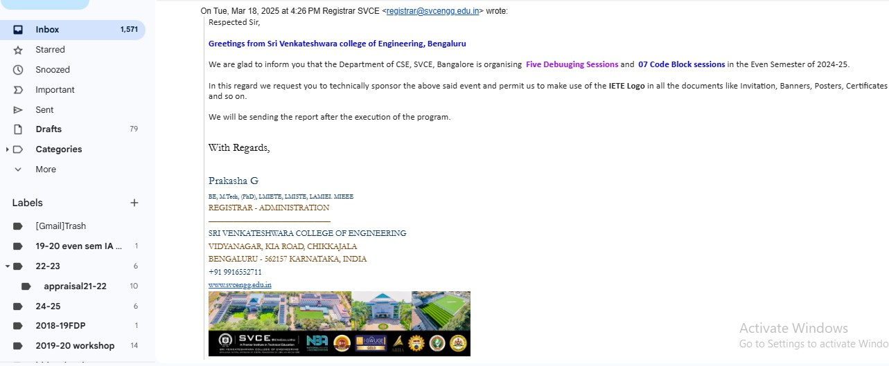

**Event invitation and/or Agenda**

|  |
| --- |
| Topic |
| 1. Explore tools and technologies like ChatGPT, DALL·E, and more (1 Hour) 2. Ethical & Social Implications (1 hour) 3. Spark innovation through hands-on projects (2 hours) |

**Program Overview**

The **Seminar** is a skill enhancement initiative designed to bridge the gap between academics and industry. It focuses on innovative learning, career moulding, and hands-on coding sessions for students from CSE department at Sri Venkateshwara College of Engineering. it helps students to gain advanced knowledge, and improve placement opportunities.

With structured execution plans, including optional Saturday skill sessions, the program aims to boost confidence, problem-solving abilities, and employability. It also supports NBA and NAAC accreditation by aligning academic learning with industry needs.

The Seminar on topic “**Contemporary Applications in Generative AI**”. It was associated with hands on session learning **on GEN-AI**, this session students will be able to Understand the capabilities and limitations of Gen AI ,Gain hands-on experience with AI tools, Critically analyze AI’s impact on society ,Be inspired to use AI responsibly in creative or academic projects.

**Program Objectives**

* **To provide a foundational understanding of Generative AI technologies**, including how they work, their capabilities, and their growing influence in various fields.
* **To familiarize students with popular Generative AI tools and platforms** through hands-on experiences in text generation, image creation, coding assistance, and more.
* **To foster creativity and innovation** by encouraging students to explore how Generative AI can be used to express ideas, solve problems, and develop original content.
* **To build AI literacy and responsible digital citizenship**, helping students critically evaluate AI-generated content and understand the ethical implications of using AI tools

The objective of this session of the program is to equip participants with hands-on expertise in **Generative AI tools and platforms**. Through this session, learners will gain practical knowledge of exploring how Generative AI can be used to express ideas, solve problems, and develop original content. This training aims to bridge the gap between GEN AI and traditional courses.

**Program Outcomes**

Students will be able to-

CO1. Identify the problems where the adaptation of AI has significant impact. CO2. Analyse the different approaches of Knowledge Representation.

CO3. Explain Symbolic Reasoning under Uncertainty and Statistical reasoning. CO4. Derive the importance of different types of Learning Techniques.

CO5. Explain Natural Language Processing and Expert System.

**Outcomes Mappings**

|  |  |  |  |  |  |  |  |  |  |  |  |  |  |
| --- | --- | --- | --- | --- | --- | --- | --- | --- | --- | --- | --- | --- | --- |
|  | **PO1** | **PO2** | **PO3** | **PO4** | **PO5** | **PO6** | **PO7** | **PO8** | **PO9** | **PO10** | **PO11** | **PSO1** | **PSO2** |
| **CO1** | **3** | **2** | **3** | **2** | **3** | **2** |  |  | **2** | **1** |  | **2** | **2** |
| **CO2** | **3** | **3** | **3** | **2** | **3** | **2** |  |  | **2** | **1** |  | **2** | **2** |
| **CO3** | **3** | **2** | **3** | **2** | **3** | **2** |  |  | **2** | **1** |  | **2** | **2** |
| **CO4** | **3** | **2** | **3** | **2** | **3** | **2** |  |  | **2** | **1** |  | **2** | **2** |
| **CO5** | **3** | **3** | **3** | **2** | **3** | **2** |  |  | **2** | **1** |  | **2** | **2** |

**Key Takeaways of the Program**

The session is design to deliver theory and with Hands-on Experience on Applications of Generative AI. Concepts covered are:

* Recap key concepts: Basics of Gen AI
* Applications in Healthcare : Gen AI in medical Advancements.
* Applications in Finance.
* Applications in Manufacturing.
* Applications in Retail and E-Commerce.
* Applications in Entertainment and Media.
* Impact on the workforce and Economy.
* Ethical considerations and challenges.
* Future of Generative AI: Trends and Innovations.

**Topics Covered (schedule)**

The topics covered under S**eminar** – **Contemporary Applications in Generative AI** are listed in the table given:

|  |
| --- |
| Topic |
| 1. Explore tools and technologies like ChatGPT, DALL·E, and more (1 Hour) 2. Ethical & Social Implications (1 hour) 3. Spark innovation through hands-on projects (2 hours)   **Program Highlights** |

* **Introduction & Objectives**: The SDP began with a welcome address, highlighting the importance of Learning Management System and Applications of Gen AI.
* **Advanced Concepts**: To Explore tools and technologies like ChatGPT, DALL·E, and more.
* **Hands-on Learning**: To Design a LMS System from scratch by forming a group of 4 members and specify the industry and type of Company. To create a one page document to define LMS using recent technology.
* **Assessment**: Assessment conducted to know the attainment of learning outcome through Quiz.
* **Expert Guidance**: Led by Mr. Sujeet Kumar the sessions provided insights from real- world industry experience and best practices.

**Proceedings**

**12th April 2025: By-Mr. Sujeet Kumar** Infosys Limited, Amsterdam, NL Head of AML, KYC Delivery, Large European Bank, Bengaluru, Karnataka

The program has started by welcoming the participants and introduction of the event. The need and scope of the SDP was stressed upon and also set the objectives of the workshop. The speaker of the day was **Mr. Sujeet Kumar** who has 19 years of experience Financial Services in Europe and India. He has a cross-domain experience in detecting financial crimes’ solution using data enhancements and data sanitization, content management with big data solutions.

The session gave an emphasis on the basics of Learning Management System overview.

The session also gave an emphasis on Core skills of AI, Exploring tools and technologies like

ChatGPT, DALL·E, and Placements.

Overview of contents covered are as follows:

Theory and Interactive Session (4 Hours)

1. Continuation of LMS Design (1 hour) Core skills required in future.
2. Advanced concepts (1 hour)

Explore AI tools and technologies like ChatGPT, DALL·E , placements and interviews.

Hands-On Session (2 Hours)

Discussion of development of attendance marking system and the role of AI in the

same.

**Feedback**

The response and feedback for this program was overwhelming. Details are furnished in the Annexure. The event offered a good Generative AI platform to the students of various departments leading to excellent learning experience.

It is mentioned by the participants that all the resource persons were of repute in their respective fields and the knowledge imparted by them was very useful in their forthcoming opportunity endeavors.

Participants Feedback details have been enclosed in the Annexure-II. Feedback overview

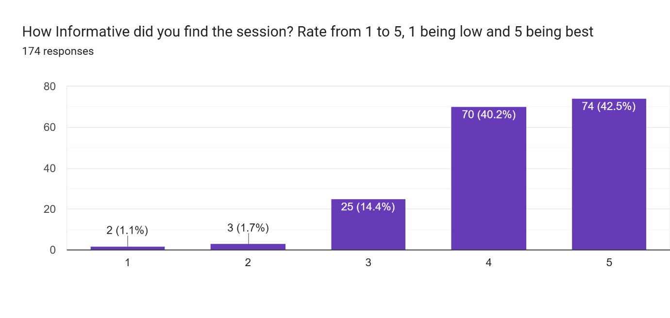

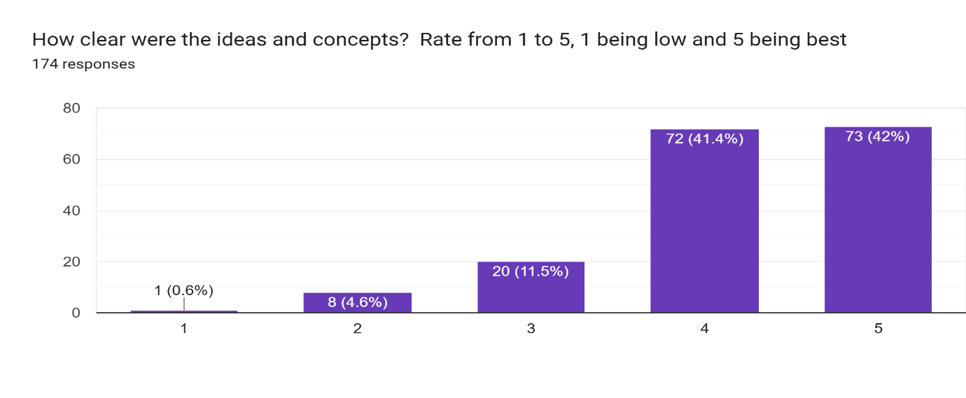

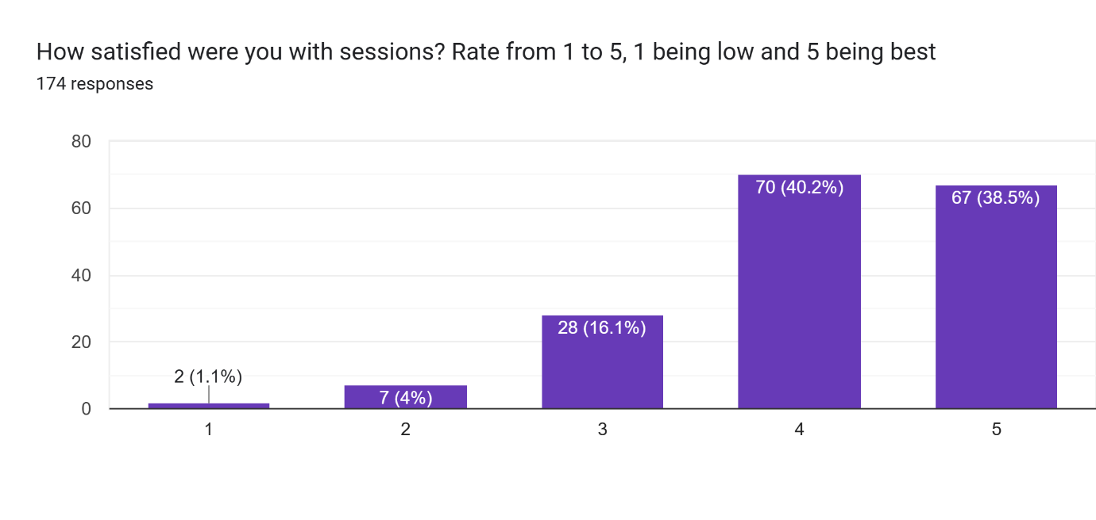

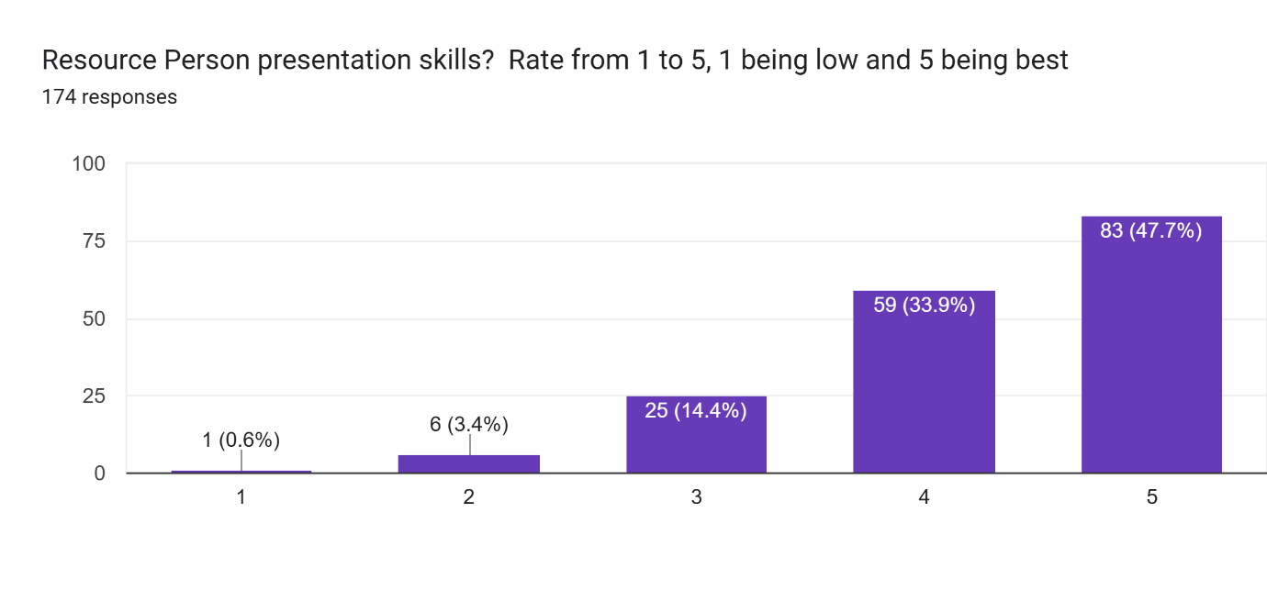

**Best Practices**

The following are the few best practices followed in order to make the program a grand success:

1. Every session has started on-time as per the schedule given.
2. Involved all departments’ students who are interested to up skill themselves.
3. Session wise assignment, assessment and other learning material were shared on-time with the participants.

**Gratitude and Thanks Note**

We express our sincere gratitude to the college management, our beloved Principal Dr B M Shathish, for recognizing the importance of continuous learning and growth and helping and supporting us to make the event a successful one.

We extend our heartfelt gratitude to the resource person Sujeet Kumar for his sincere effort to lead the event till excellence.

Special thanks to Dr. Mukesh Kumar Singh, HoD, CSE and the organizing team for seamless coordination, and all attendees for their commitment to enhancing their skills. We appreciate your dedication and look forward to continued learning and collaboration.

We want to thank the teaching and non-teaching staff of the Dept. of CSE, Administration and support staff of the Sri Venkateshwara College of Engineering, Bengaluru for their support in organizing the program.

**Annexure-I: List of Participants and attendance copy (original).**

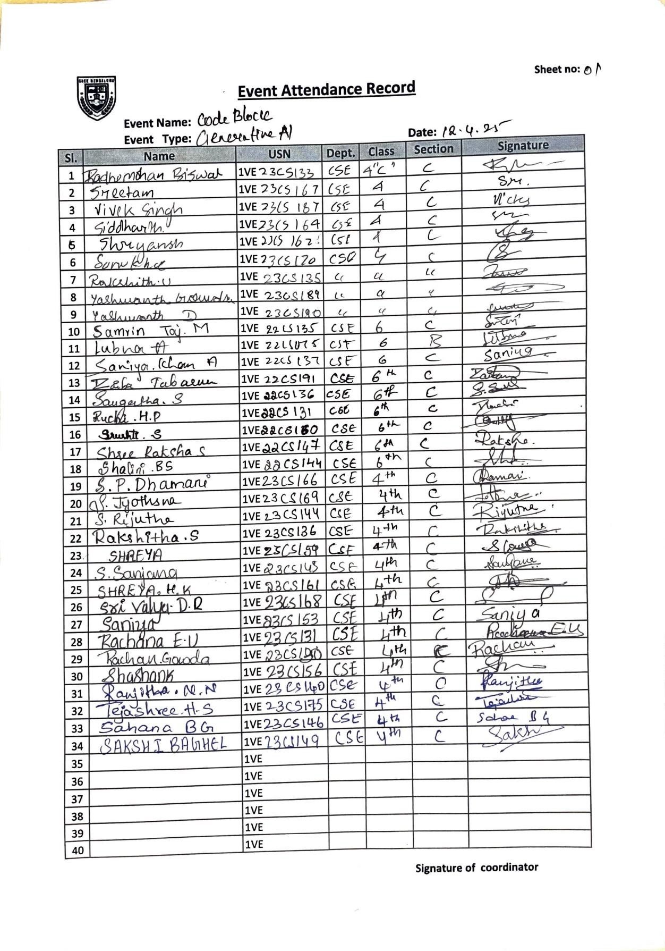

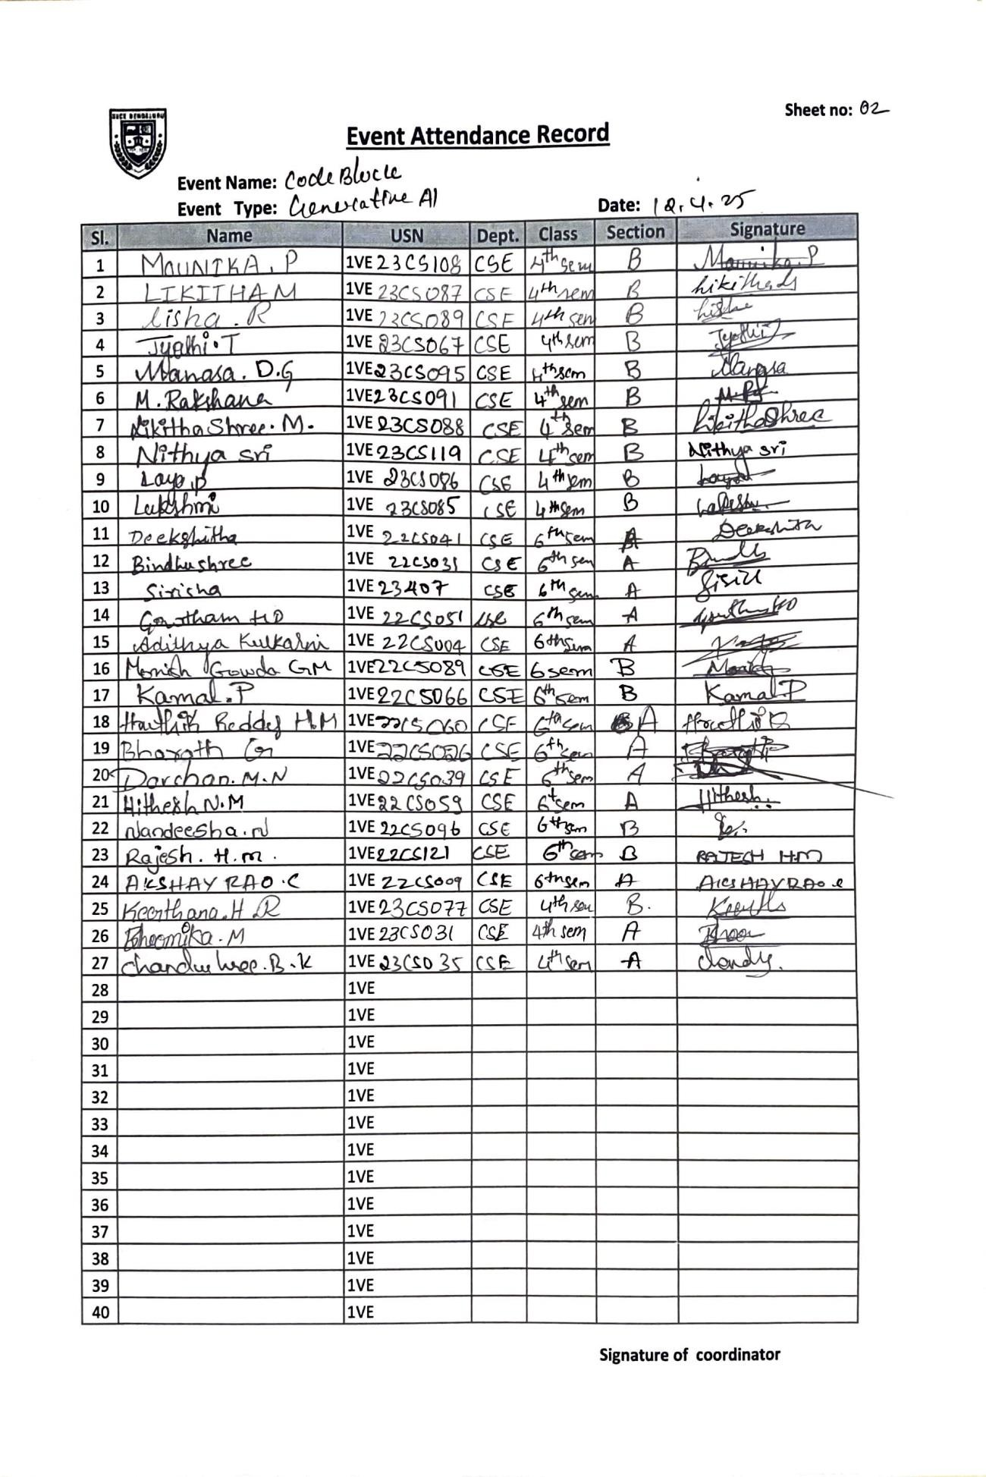

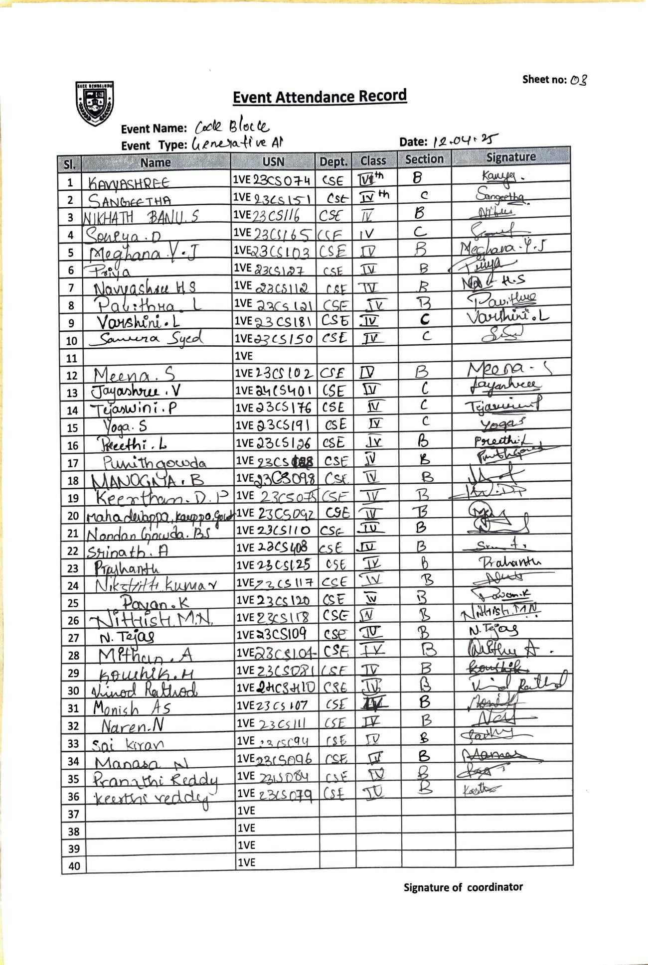

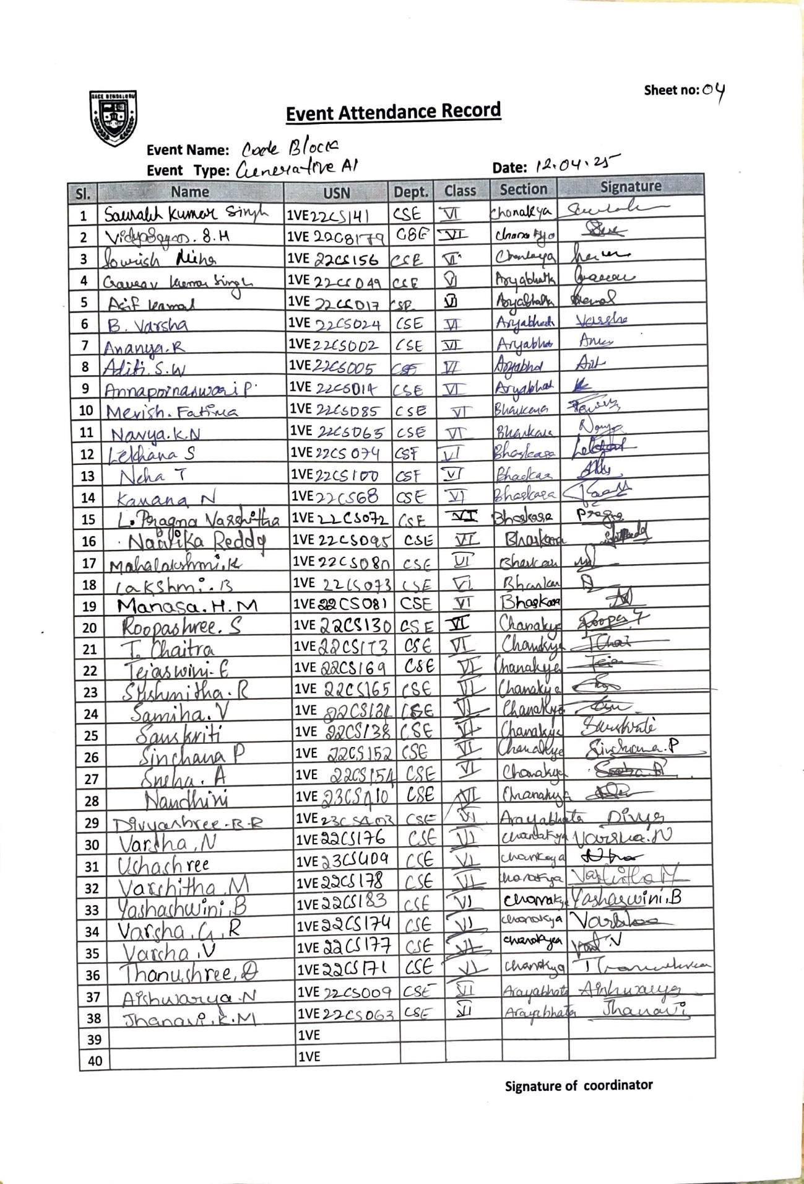

**Annexure-II: Feedback filled sample forms/Worksheets**

**FEEDABCK ON GENERATIVE AI SESSION CONDUCTED ON 12-04-2025**









|  |  |  |  |  |  |  |  |
| --- | --- | --- | --- | --- | --- | --- | --- |
| Timestamp | NAME OF THE STUDENT | USN OF THE STUDENT | How Informative did you find the session? Rate from 1 to 5, 1 being low and 5 being best | How clear were the ideas and concepts? Rate from 1 to 5, 1 being low and 5 being best | How satisfied were you with sessions? Rate from 1 to 5, 1 being low and 5 being best | Resource Person presentation skills? Rate from 1 to 5, 1 being low and 5 being best | Takeaway from the session? |
| -2025/04/15 2:19:40 PM GMT+5:30 | Srushti S | 1VE22CS160 | 3 | 4 | 3 | 3 | . |
| 2025/04/15 12:34:26 PM GMT+5:30 | Nikshith kumar M | IVE23CS117 | 5 | 5 | 5 | 5 | Nil |
| 2025/04/15 12:33:40 PM GMT+5:30 | Nikshith kumar M | Ive23cs117 | 5 | 5 | 5 | 5 | Nil |
| 2025/04/15 11:06:43 AM GMT+5:30 | K N Navya | 1VE22CS065 | 5 | 4 | 4 | 4 | It was informative |
| 2025/04/15 11:04:05 AM GMT+5:30 | Suhas P R | 1VE22CS164 | 4 | 4 | 4 | 4 | Takeaway |
| 2025/04/15 10:58:12 AM GMT+5:30 | ADITHYA KULKARNI | 1VE22CS004 | 4 | 4 | 4 | 4 | Understanding about learning management system(LMS) |
| 2025/04/15 10:52:28 AM GMT+5:30 | Lakshmi | 1VE23CSO85 | 5 | 5 | 5 | 5 | Ntg |
| 2025/04/15 10:50:21 AM GMT+5:30 | VENKAT NARAYAN T L | 1VE23CS182 | 5 | 5 | 4 | 5 | . |
| 2025/04/15 10:46:36 AM GMT+5:30 | Rahul Subhash katageri | 1VE23CS134 | 3 | 3 | 3 | 3 | Nil |
| 2025/04/15 10:46:33 AM GMT+5:30 | SHREYA | 1VE23CS159 | 4 | 4 | 4 | 4 | . |
| 2025/04/15 10:46:25 AM GMT+5:30 | RavindraReddy N B | 1VE24CS405 | 4 | 4 | 5 | 4 | No |
| 2025/04/15 10:46:19 AM GMT+5:30 | WAHID ALI | 1VE24CS411 | 4 | 4 | 4 | 4 | Gained knowledge |
| 2025/04/15 10:46:06 AM GMT+5:30 | Vishnu J | 1VE23CS186 | 4 | 4 | 4 | 4 | . |
| 2025/04/15 10:45:55 AM GMT+5:30 | Sahana HB | 1VE23CS147 | 2 | 2 | 2 | 2 | About generative AI |
| 2025/04/15 10:45:51 AM GMT+5:30 | RANJITHA G | 1VE23CS139 | 4 | 4 | 4 | 4 | . |
| 2025/04/15 10:45:50 AM GMT+5:30 | Shreya HK | 1VE23CS161 | 5 | 4 | 5 | 4 | It was informative |
| 2025/04/15 10:45:43 AM GMT+5:30 | Pavan gowda yn | 1VE24CS4404 | 3 | 3 | 3 | 4 | No |
| 2025/04/15 10:45:42 AM GMT+5:30 | Ranjitha N N | 1VE23CS140 | 5 | 5 | 5 | 5 | . |
| 2025/04/15 10:45:42 AM GMT+5:30 | SAHANA B G | 1VE23S146 | 3 | 3 | 3 | 3 | Ai |
| 2025/04/15 10:45:27 AM GMT+5:30 | Jayashree V | 1VE24CS401 | 5 | 5 | 5 | 5 | . |
| 2025/04/15 10:45:14 AM GMT+5:30 | Susmita Das | 1ve23cs172 | 4 | 4 | 4 | 4 | Informative |
| 2025/04/15 10:45:13 AM GMT+5:30 | TEJASWINI P | 1VE23CS176 | 4 | 4 | 4 | 4 | ..... |
| 2025/04/15 10:45:10 AM GMT+5:30 | Varshini L | 1VE23CS181 | 5 | 5 | 4 | 5 | . |
| 2025/04/15 10:45:07 AM GMT+5:30 | Shreya A | 1VE23CS160 | 5 | 5 | 5 | 5 | Good |
| 2025/04/15 10:45:04 AM GMT+5:30 | Venkat p | 1ve23cs183 | 4 | 4 | 4 | 4 | ... |
| 2025/04/15 10:45:03 AM GMT+5:30 | Teja B | 1VE23CS173 | 5 | 5 | 5 | 5 | Good information |
| 2025/04/15 10:44:57 AM GMT+5:30 | TEJASHREE H S | 1VE23CS175 | 3 | 4 | 3 | 3 | - |
| 2025/04/15 10:44:50 AM GMT+5:30 | Yoga S | 1VE23CS191 | 2 | 2 | 2 | 3 | . |
| 2025/04/15 10:44:49 AM GMT+5:30 | RANJITHA G | 1VE23CS139 | 4 | 4 | 4 | 4 | . |
| 2025/04/15 10:44:46 AM GMT+5:30 | Vikas barigidad | 1VE23CS185 | 2 | 2 | 2 | 2 | No |
| 2025/04/15 10:44:23 AM GMT+5:30 | Sumukha s | 1ve23cs170 | 4 | 4 | 4 | 4 | Learning of lms |
| 2025/04/14 12:35:49 PM GMT+5:30 | Ranjith E | 1VE23CS138 | 3 | 3 | 3 | 3 | Good |
| 2025/04/13 9:17:11 AM GMT+5:30 | Ananya.R | 1ve23cs011 | 5 | 5 | 5 | 5 | Session was informative |
| 2025/04/13 9:16:44 AM GMT+5:30 | Chaithanya.kvm | 1VE23CS034 | 5 | 5 | 4 | 4 | .. |
| 2025/04/13 9:14:51 AM GMT+5:30 | Dheeraj Gowda YS | 1VE23CS049 | 4 | 4 | 4 | 4 | About unknown artificial intelligence and who it can increase our productivity. |
| 2025/04/13 9:06:54 AM GMT+5:30 | CHIRANJEEVI YADAV | 1VE23CS040 | 5 | 5 | 5 | 5 | Good |
| 2025/04/13 9:03:33 AM GMT+5:30 | Sahana B G | 1VE23CS146 | 3 | 4 | 3 | 5 | Ai |
| 2025/04/13 9:01:43 AM GMT+5:30 | Darshan A | 1VE23CS043 | 5 | 5 | 5 | 5 | Good learning session on generative AI |
| 2025/04/13 9:01:10 AM GMT+5:30 | M.Rakshana | 1VE23CS091 | 5 | 5 | 5 | 5 | Nothing |
| 2025/04/13 8:56:41 AM GMT+5:30 | SHRI Lashmi S J | 1VE23CS163 | 5 | 5 | 5 | 5 | Got to know about so many things |
| 2025/04/13 8:56:17 AM GMT+5:30 | Likithashree M | 1VE23CS088 | 4 | 4 | 5 | 5 | - |
| 2025/04/13 7:02:06 PM GMT+5:30 | Hardhik Shetty R | 1VE23CS059 | 5 | 5 | 5 | 5 | NA |
| 2025/04/13 4:46:27 PM GMT+5:30 | SHALINI B S | 1VE22CS144 | 3 | 3 | 4 | 4 | - |
| 2025/04/13 4:21:18 PM GMT+5:30 | Niharika ca | 1VE22CS101 | 5 | 5 | 5 | 5 | Informative |
| 2025/04/13 3:45:05 PM GMT+5:30 | KOUSHIK M | 1VE23CS081 | 4 | 4 | 4 | 4 | _- |
| 2025/04/13 3:03:08 PM GMT+5:30 | Rakshitha S | 1VE23CS136 | 5 | 4 | 4 | 5 | . |
| 2025/04/13 2:59:08 PM GMT+5:30 | Ananya Kanthraj | 1VE22CS011 | 5 | 5 | 5 | 5 | Nil |
| 2025/04/13 2:47:39 PM GMT+5:30 | LISHA R | 1ve23cs089 | 4 | 3 | 3 | 3 | Na |
| 2025/04/13 2:47:10 PM GMT+5:30 | SHREYAS V | 1VE22CS149 | 5 | 5 | 4 | 3 | Need more hands-on training |
| 2025/04/13 2:29:34 PM GMT+5:30 | NAVNEET KUMAR | 1VE22CS098 | 5 | 5 | 5 | 5 | Nice |
| 2025/04/13 2:19:35 PM GMT+5:30 | TEJASWINI P | 1VE23CS176 | 5 | 5 | 5 | 5 | .... |
| 2025/04/13 12:58:11 PM GMT+5:30 | Harsh | 1VE23CS062 | 4 | 4 | 4 | 4 | . |
| 2025/04/13 12:43:32 PM GMT+5:30 | Samrin Taj M | 1VE22CS135 | 4 | 4 | 4 | 4 | It was informative |
| 2025/04/13 12:22:34 PM GMT+5:30 | Adithi Shridhara | 1VE22CS003 | 5 | 5 | 5 | 5 | More information about AI |
| 2025/04/13 12:11:12 PM GMT+5:30 | Shreya HK | 1VE23CS161 | 4 | 5 | 4 | 5 | It was informative and useful |
| 2025/04/13 12:05:19 PM GMT+5:30 | ROOPASHREE S | 1VE22CS130 | 5 | 4 | 4 | 5 | - |
| 2025/04/13 12:00:02 PM GMT+5:30 | Kavana N | 1VE22CS068 | 4 | 4 | 5 | 5 | ... |
| 2025/04/13 11:53:44 AM GMT+5:30 | Laya.p | 1VE23CS086 | 5 | 5 | 5 | 4 | No |
| 2025/04/13 11:32:27 AM GMT+5:30 | Shakeer pasha | 1VE22CS143 | 4 | 5 | 4 | 4 | . |
| 2025/04/13 11:17:59 AM GMT+5:30 | NISHANTH A | 1ve22cs106 | 4 | 4 | 4 | 4 | Yes |
| 2025/04/13 11:17:15 AM GMT+5:30 | Varsha N | 1VE22CS176 | 5 | 5 | 5 | 5 | GenAi |
| 2025/04/13 11:17:04 AM GMT+5:30 | Chaithanya D | 1VE22CS034 | 3 | 4 | 3 | 4 | Got little info about Generative AI |
| 2025/04/13 11:16:37 AM GMT+5:30 | BHOOMIKA M C | 1VE22CS029 | 3 | 4 | 4 | 3 | .... |
| 2025/04/13 11:13:27 AM GMT+5:30 | Poornima.R | 1VE23CS122 | 5 | 5 | 5 | 5 | Nothing |
| 2025/04/13 11:12:14 AM GMT+5:30 | Ravi Ranjan Kumar Yadav | 1ve22cs125 | 3 | 3 | 3 | 3 | No |
| 2025/04/13 11:08:38 AM GMT+5:30 | Srujan NM | 1VE22CS158 | 5 | 5 | 5 | 5 | Good |
| 2025/04/13 11:07:06 AM GMT+5:30 | Amar Biradar | 1VE22CS010 | 5 | 5 | 5 | 5 | LMS |
| 2025/04/13 11:06:42 AM GMT+5:30 | DIVYASHREE B R | 1VE23CS403 | 5 | 5 | 5 | 5 | Good |
| 2025/04/13 11:05:34 AM GMT+5:30 | Gangothri | 1VE23CS055 | 4 | 4 | 4 | 4 | - |
| 2025/04/13 11:04:57 AM GMT+5:30 | Naivika Reddy | 1VE22CS095 | 5 | 5 | 5 | 5 | Nothing |
| 2025/04/13 11:00:00 AM GMT+5:30 | Aditi Sunil Warrier | 1VE22CS005 | 5 | 5 | 5 | 5 | nil |
| 2025/04/13 10:59:13 AM GMT+5:30 | LEKHANA S | 1VE22CS074 | 4 | 4 | 4 | 4 | Information about the no code and low codes , how GENAI is used in the other apps eg: shopping apps .Totally i gained some knowledge from this session |
| 2025/04/13 10:55:27 AM GMT+5:30 | Varsha G R | 1VE22CS174 | 5 | 5 | 5 | 5 | Basis of gen AI ,real world applications, implementation of LMS |
| 2025/04/13 10:55:26 AM GMT+5:30 | G S Netra | 1VE22CS047 | 5 | 5 | 5 | 5 | Helpful session |
| 2025/04/13 10:54:39 AM GMT+5:30 | PILLIKANDLA VENKATA NAGA MANIDEEP | 1ve | 4 | 4 | 4 | 5 | Great |
| 2025/04/13 10:51:10 AM GMT+5:30 | Anjali | VE23CS016 | 5 | 5 | 5 | 5 | Good |
| 2025/04/13 10:49:07 AM GMT+5:30 | Bhoomika M | 1VE23CS031 | 3 | 3 | 3 | 3 | . |
| 2025/04/13 10:48:00 PM GMT+5:30 | ASIF KAMAL | 1VE22CS017 | 5 | 5 | 3 | 2 | Current uses and scope of Gen AI |
| 2025/04/13 10:37:47 AM GMT+5:30 | AYUSH KUMAR | 1VE23CS022 | 5 | 5 | 5 | 5 | Got to think of a different perspective on looking into problems |
| 2025/04/13 10:30:29 AM GMT+5:30 | Jyothi.T | 1VE23CS067 | 5 | 5 | 5 | 5 | It was so good and it motivated us |
| 2025/04/13 10:25:48 AM GMT+5:30 | Harisankara Sai Nandan | 1ve23cs060 | 5 | 5 | 5 | 5 | Nnnsmma |
| 2025/04/13 10:22:49 AM GMT+5:30 | Ankita | 1VE23CS017 | 4 | 4 | 4 | 4 | . |
| 2025/04/13 10:19:30 AM GMT+5:30 | BHOOMIKA V | 1VE23CS032 | 5 | 5 | 5 | 5 | - |
| 2025/04/13 10:17:41 AM GMT+5:30 | Soniya D | 1VE23CS165 | 4 | 4 | 4 | 4 | Coding skills |
| 2025/04/13 10:16:30 AM GMT+5:30 | SRUNGARAPU SIVA SAI JYOTHSNA | 1VE23CS169 | 4 | 3 | 3 | 4 | Insights of generative AI |
| 2025/04/13 10:14:00 AM GMT+5:30 | Keerthan dp | 1ve23cs075 | 4 | 3 | 3 | 3 | Nil |
| 2025/04/13 10:02:39 AM GMT+5:30 | LIKITHA M | 1VE23CS087 | 4 | 5 | 4 | 4 | No |
| 2025/04/13 1:41:44 PM GMT+5:30 | NANDEESHA N | 1VE22CS096 | 5 | 5 | 5 | 5 | S |
| 2025/04/13 1:26:01 PM GMT+5:30 | ADITI C GOWDA | 1VE23CS004 | 5 | 5 | 5 | 5 | I have learnt so many new things of generative AI it is very useful |
| 2025/04/13 1:23:07 PM GMT+5:30 | Rajesh HM | 1VE22CS121 | 4 | 4 | 4 | 4 | Good |
| 2025/04/13 1:22:14 PM GMT+5:30 | Ganesh | 1VE22CS053 | 4 | 5 | 5 | 5 | .. |
| 2025/04/13 1:00:29 PM GMT+5:30 | NIKHIL CM | 1VE22CS102 | 4 | 3 | 4 | 2 | Helps to solve the complex problems for further projects using different algorithms. |

**Annexure-IV: Glimpses of the event (event Photos with caption)**

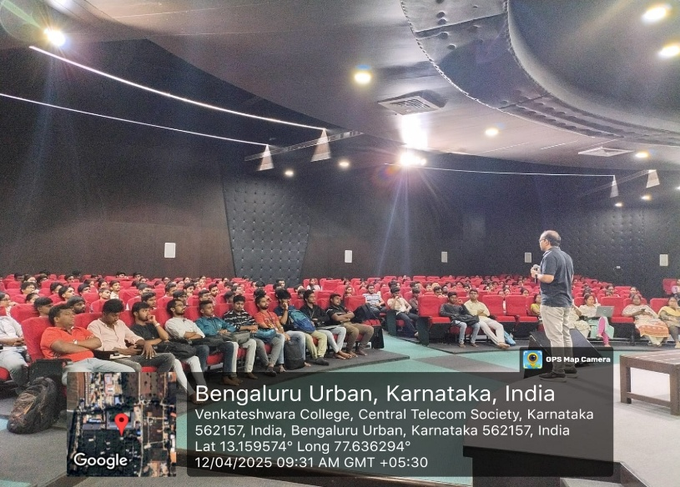 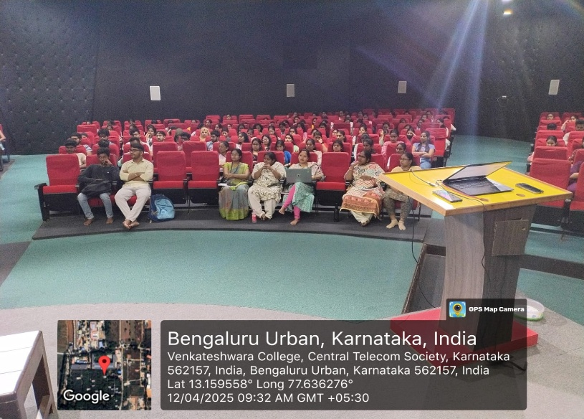

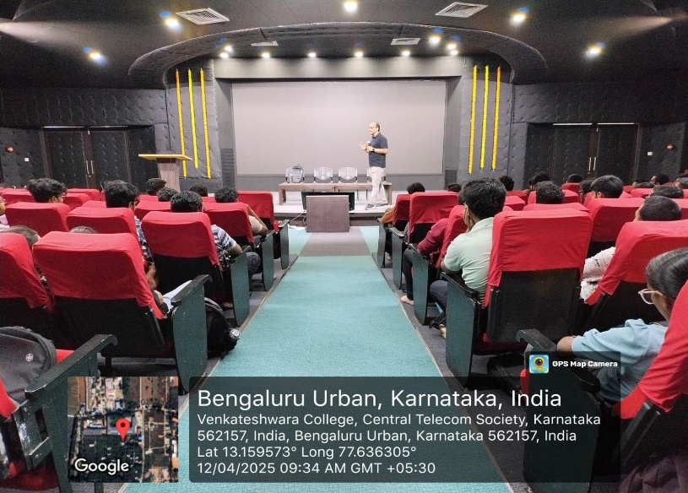 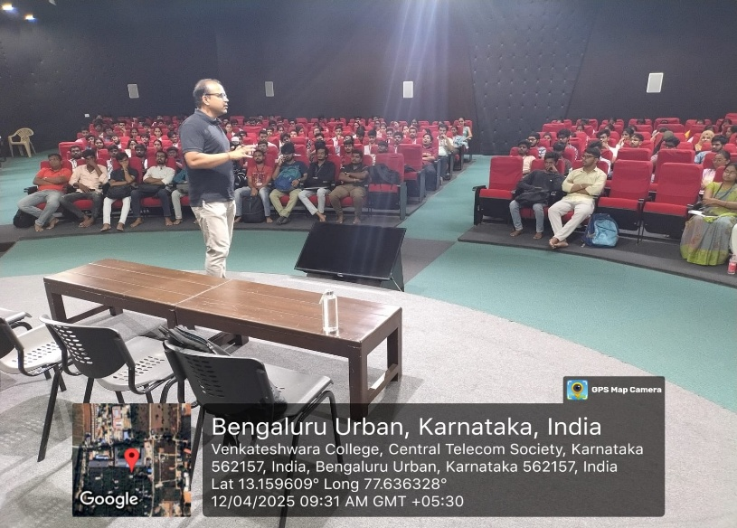

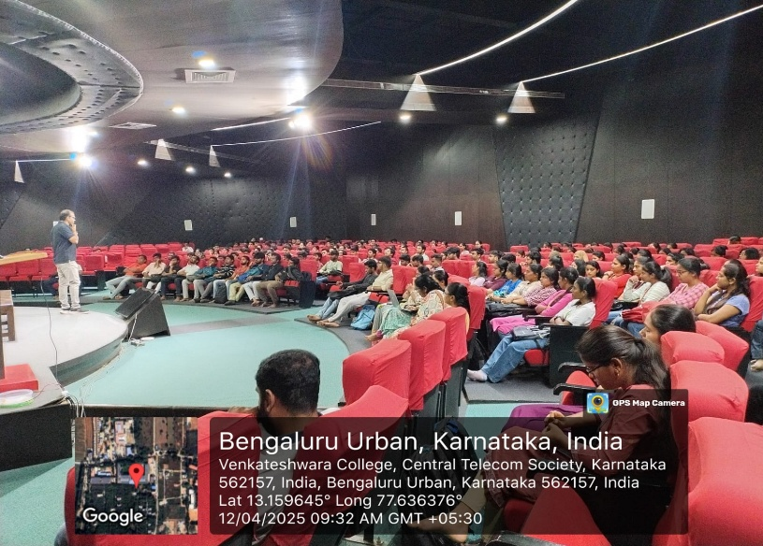 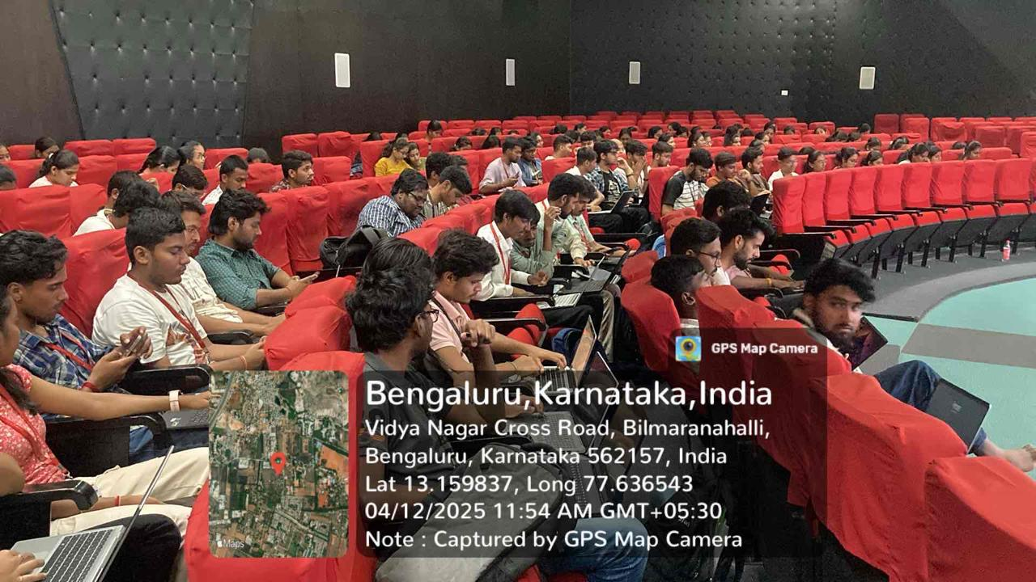

**Annexure-V: Account statements and bills of the event**

Proposed Budget:

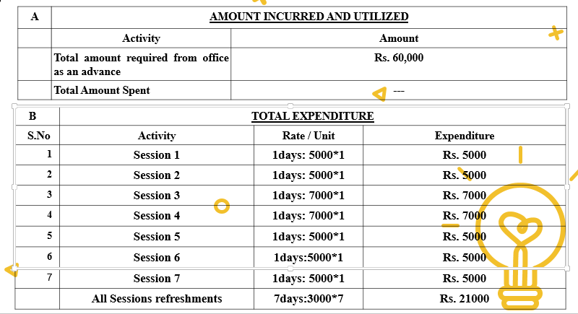

Amount paid to resource person:

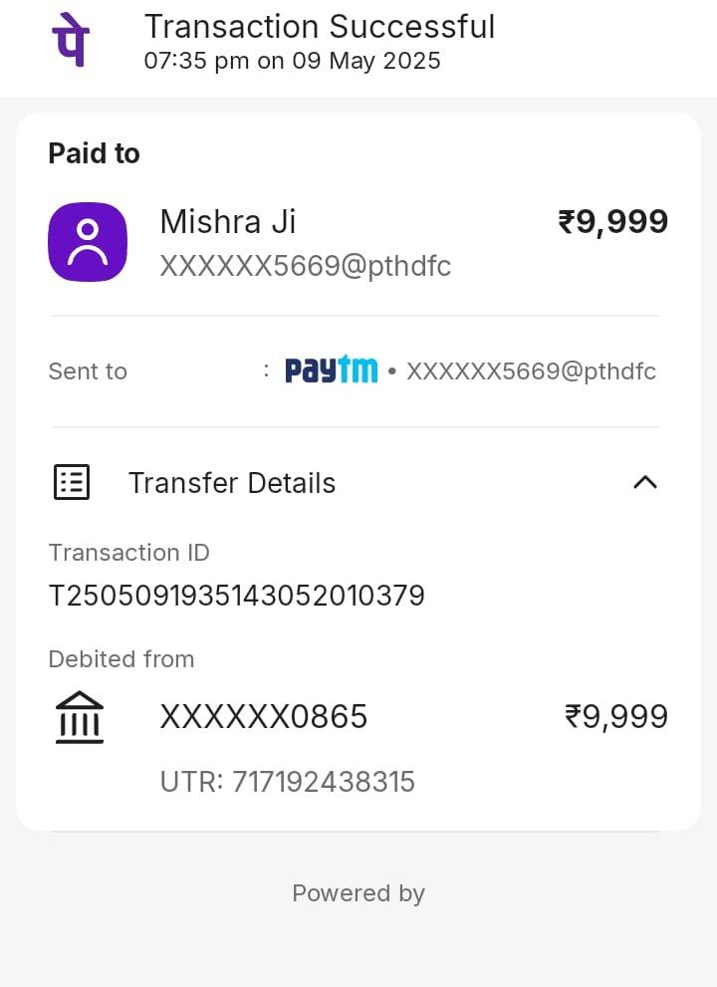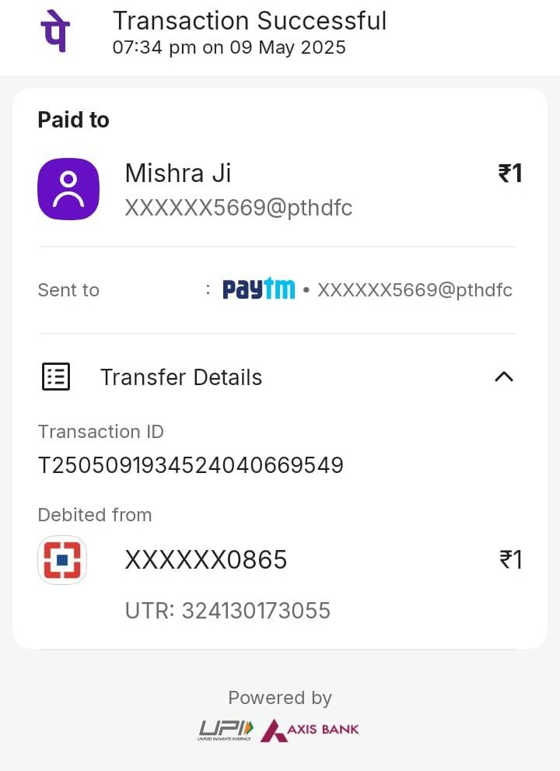

**----------------------------------End of Report----------------------------------**